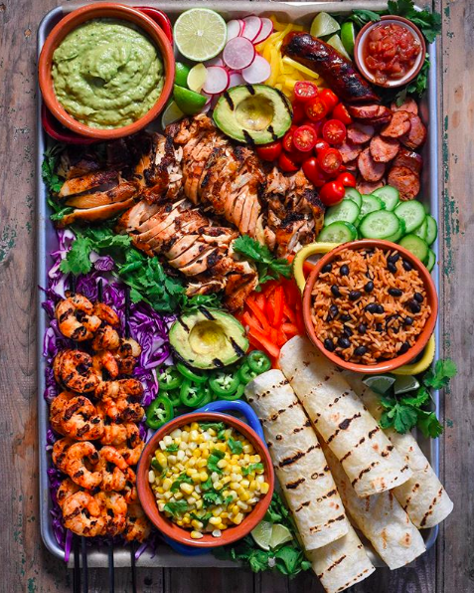

**The Battle of the Neighborhoods - Week 1**

**The Mexican Food Company Limited**

1. A description of the problem and a discussion of the background.

**Problem Description:**

Mexican food is one of the most famous cuisines worldwide. The City of New York is famous for its vast and excellent cuisines. Its food culture includes an array of international cuisines mainly influenced by the city's immigrant history.

My client ‘**The Mexican Food Company Limited**’, needs to choose their first location here very carefully and once their first venture is successful, they can replicate the same analysis and strategies in other locations throughout USA for continued expansion and growth. Being their first overseas venture, they want it to be successful and at the same time ensure the cost of the project remains low.

Anyone investing into this market should leverage from data insights to get a good understanding of the current competition for cementing a long- and short-term business strategy. This is a must to keep overheads low and getting a better ROI.

**Problem Background:**

After being a successful business in New Zealand my Client ‘**The Mexican Food Company Limited**’ is thinking of expanding globally and wants to open their first overseas restaurant in New York City, USA. Being the most populous city in the United States with population: 8.399 million (2018) and a global hub of business and commerce, this city is a major centre for big businesses in the United States. This is a highly developed city so cost of doing business is also one of the highest and is a very risky and competitive environment.

**New York City** comprises of 5 boroughs. It is diverse and is the financial capital of USA. It homes a multicultural society that provides immense business opportunities and business friendly environment for Mexican food.

**Target Audience:**

To recommend the correct location, ‘**The Mexican Food Company Limited**’ has appointed me as a lead of their Data Science team. The objective is to locate and recommend to the management which neighborhood of New York city will be best choice to start a restaurant. The Management also expects to understand the logical reasoning of the recommendations we make.

Also, this may benefit anyone who wants to start a new restaurant in New York city.

**Success Criteria:**

The success criteria of the project will be a good recommendation of borough/Neighborhood choice to ‘**The Mexican Food Company Limited**’ based on lack of such restaurants in that location and population density.

1. A description of the data and how it will be used to solve the problem.

**Data Description:** City to be analysed in this project: **New York City**.

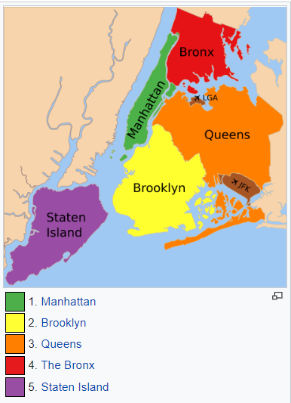

New York City comprises a total of 5 boroughs and 306 neighborhoods. In order to segment the neighborhoods and explore them, we will essentially need a dataset that contains the 5 boroughs and the neighborhoods that exist in each borough as well as the latitude and longitude coordinates of each neighborhood. Luckily, this dataset exists for free on the web: <https://geo.nyu.edu/catalog/nyu_2451_34572>.

Additionally, Foursquare data API will be used for getting different kind of venues for segmentation and clustering. New York city geographical coordinates data will be utilized as input for the Foursquare API, that will be leveraged to provision venues information for each neighborhood. We will use the Foursquare API to explore neighborhoods in New York City. The below is image of the Foursquare API data.

[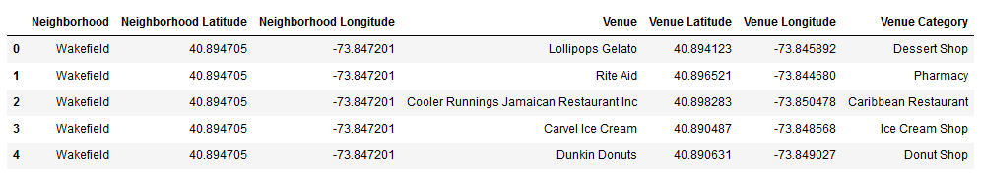](https://i.imgur.com/MOxxyoY.png)

Also, for the below analysis we will get data from Wikipedia as given below:

New York Population/ Demographics and Boroughs

Source: <https://en.wikipedia.org/wiki/Demographics_of_New_York_City>

Source: <https://en.wikipedia.org/wiki/Boroughs_of_New_York_City>